1. VS Code Installation on Windows

VS Code is one of the best Editor in the world.

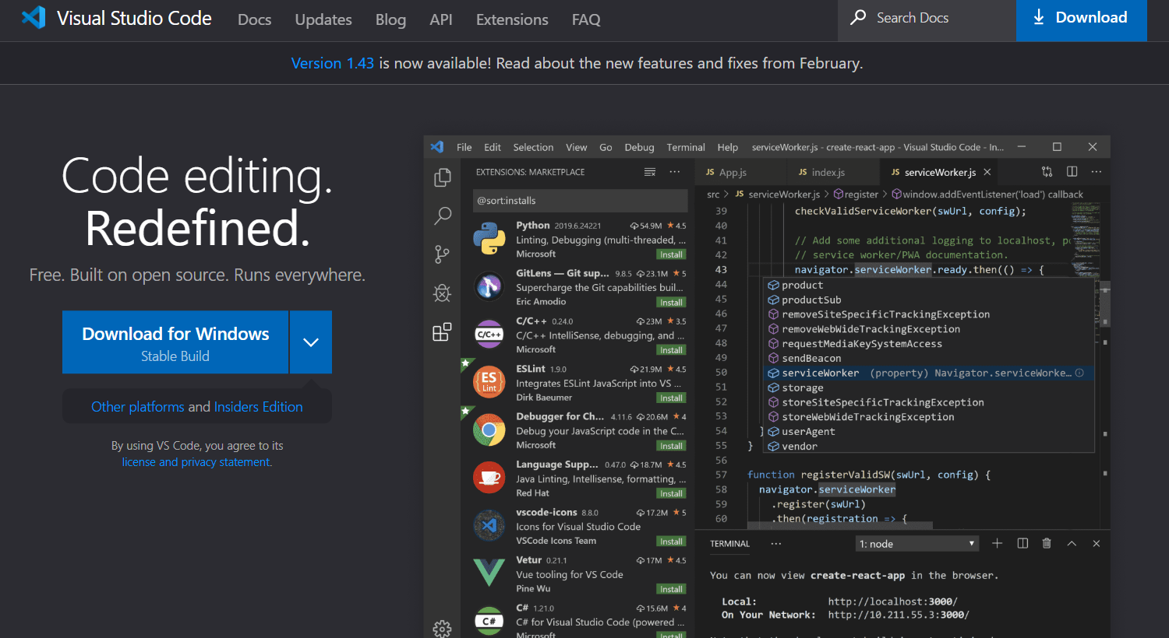

到官網下載軟體https://code.visualstudio.com/

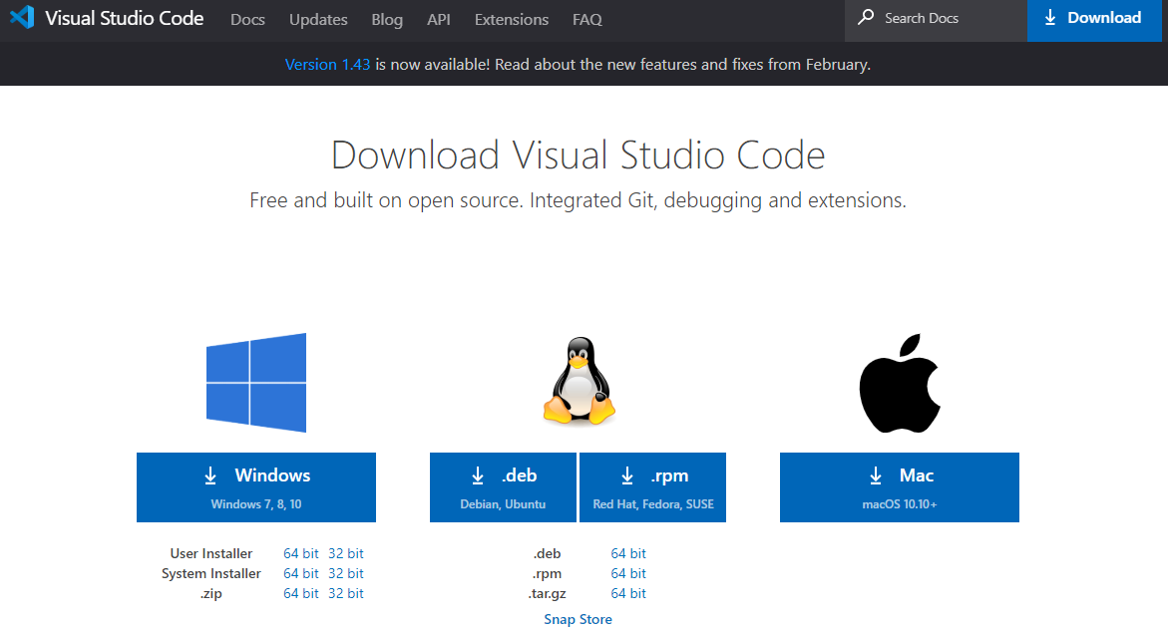

有兩個版本可以選擇，其安裝路徑與步驟稍有不同，功能完全相同。

You can download the “System installer” or “User installer.” Their installation folders are not the same.

User versus system setup

VS Code provides both Windows user and system level setups. Installing the user setup does not require Administrator privileges as the location will be under your user Local AppData (LOCALAPPDATA) folder. User setup also provides a smoother background update experience.

The system setup requires elevation to Administrator privileges and will place the installation under Program Files.

兩個版本安裝路徑不同。

我們使用“User installer”比較方便!

會詢問你安裝路徑，預設即可!

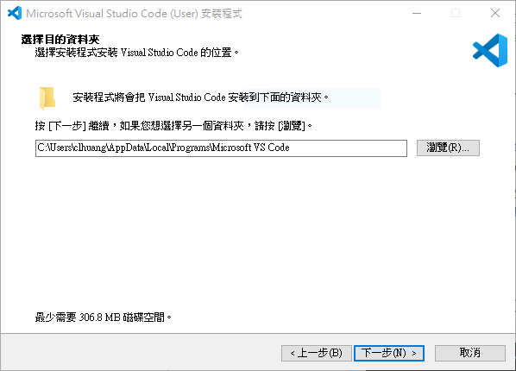

安裝路徑如下:

By default, VS Code is installed under C:\users\{username}\AppData\Local\Programs\Microsoft VS Code.

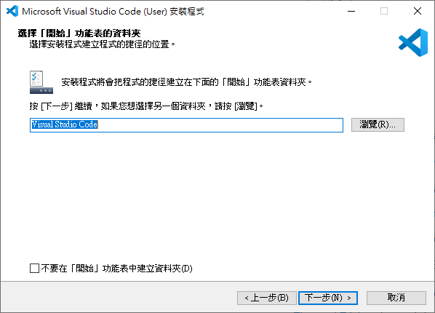

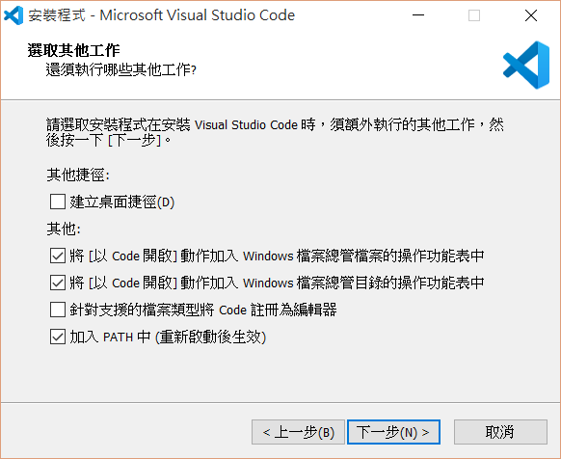

一定要打勾!!

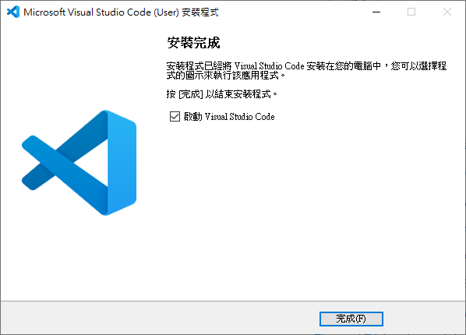

安裝完畢，進入vscode看到的畫面:

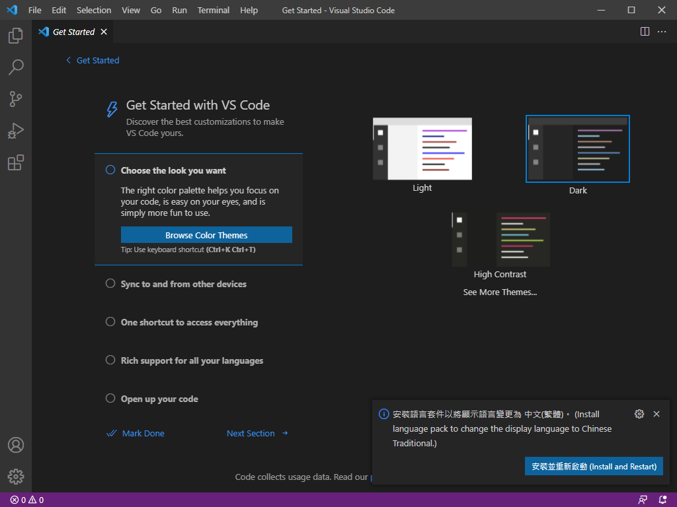

繼續安裝延伸套件(插件)

使用中文英文介面都可以。

1. The extensions you have to install

繼續安裝延伸套件(Plugin)

1. Python—by Microsoft (three extensions will be installed)

-Pylance: A performant, feature-rich language server for Python in VS Code

-Jupyter

-Black Formatter Python formatter

1. Live Server (local server for dynamic pages)
2. Django by "Baptiste Darthenay" Django code formatter
3. Prettier - Code formatter

Beautify javascript, JSON, CSS, Sass, and HTML in Visual Studio Code.

1. [Auto Rename Tag](https://marketplace.visualstudio.com/items?itemName=formulahendry.auto-rename-tag) by Jun Han  
   自動重命名配對的HTML / XML標籤

Follow the following steps: search for the packages and then install them.

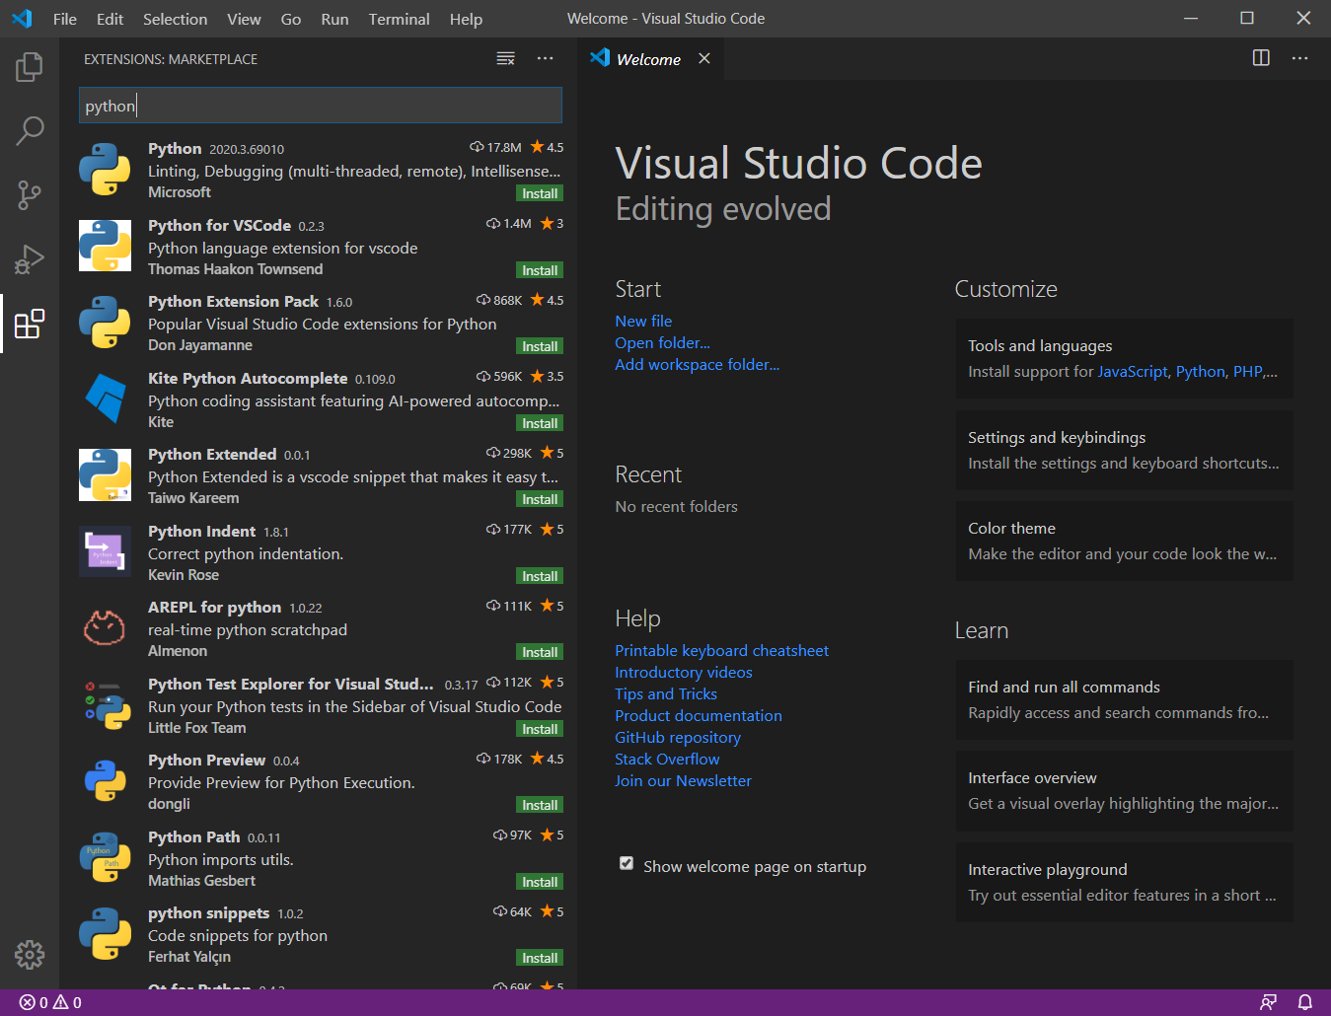

Search for “python” and install it

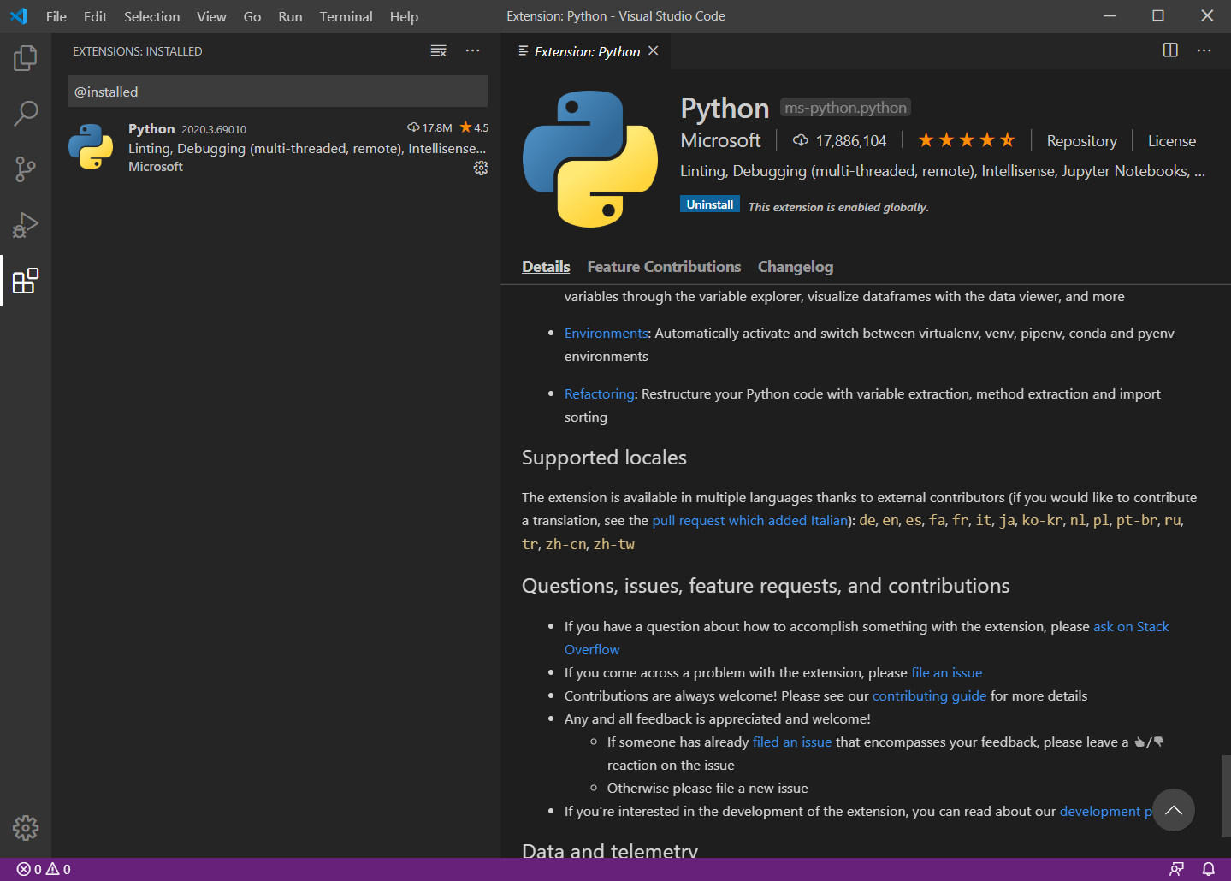

Installed python package is shown here

All extensions that we have are as follows:

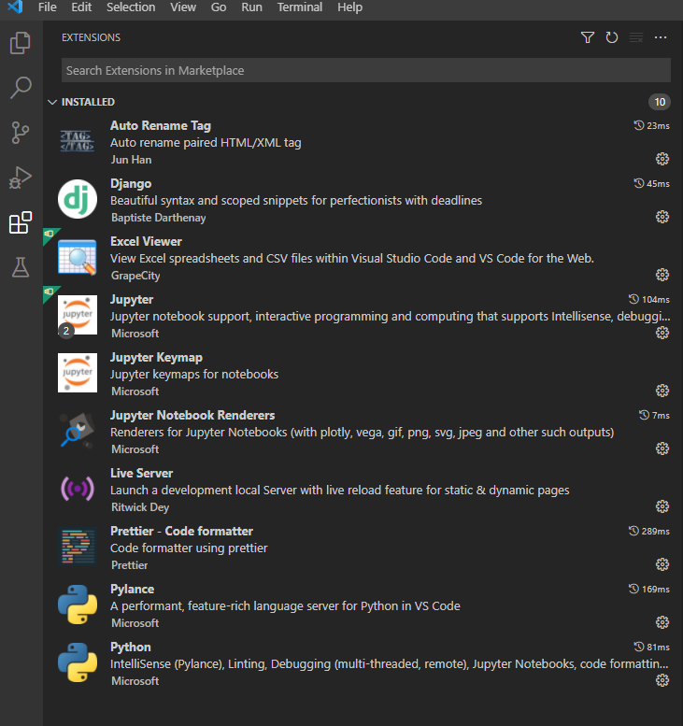

Black Formatter

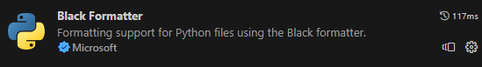

[Formatting Python in Visual Studio Code](https://code.visualstudio.com/docs/python/formatting)

Django Template html檔案格式化工具

<https://github.com/djlint/djlint-vscode>

於Python虛擬環境安裝djlint

pip install -U djlint

安裝Vscode延伸套件djLint



1. Setting and Keyboard shortcut

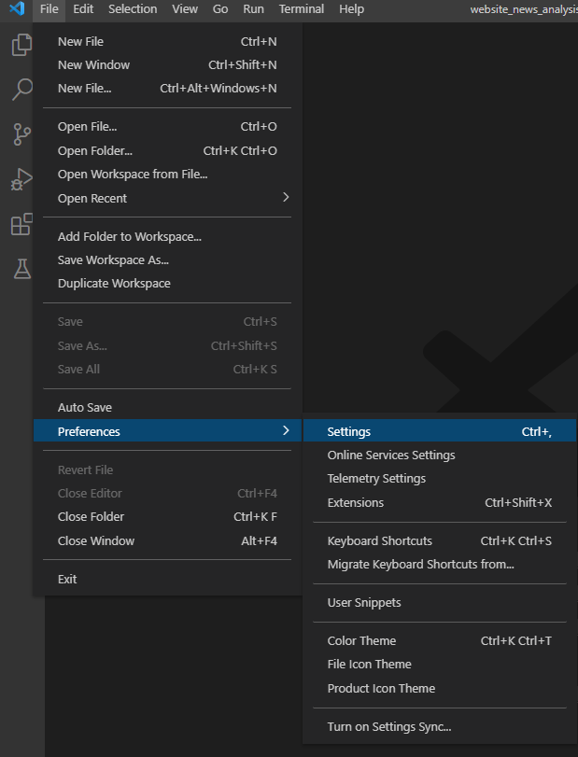

1. Word wrap

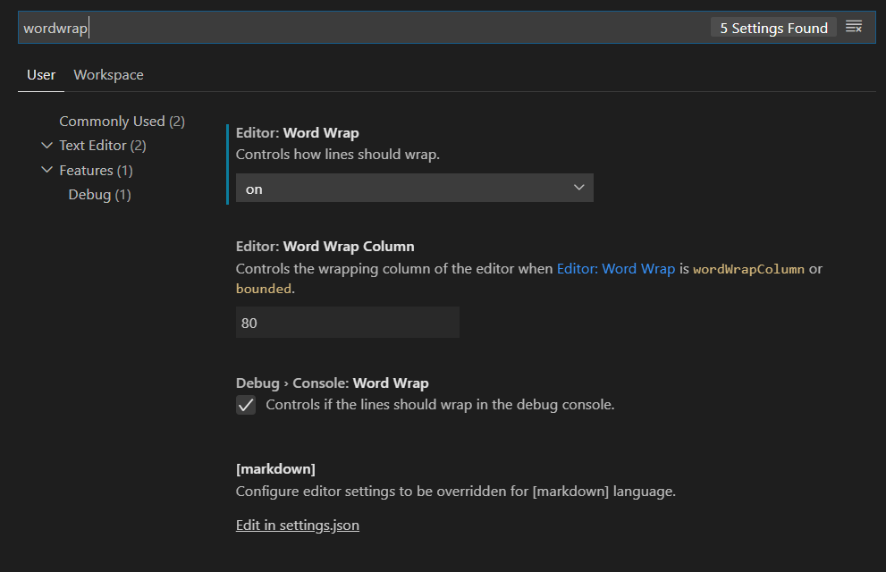

1. How To Hide __pycache__, .ini files in Explorer?

Settings --> Files exclude

Add the following patterns:

**/__pycache__

**/*.ini

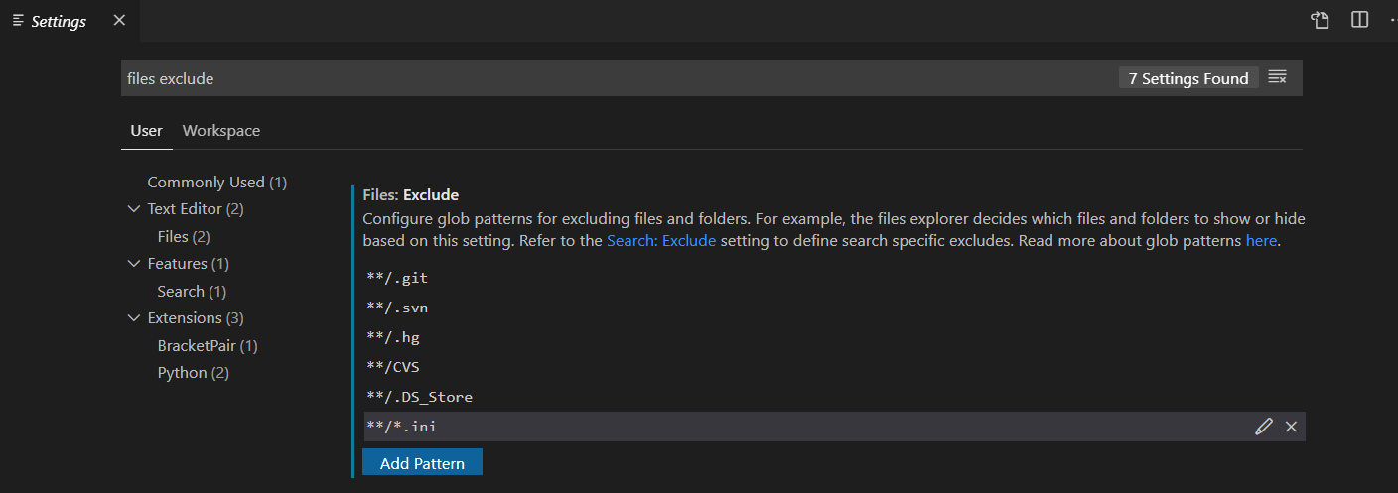

Add this pattern.

1. Terminal is OK?

Ctrl+j to open terminal

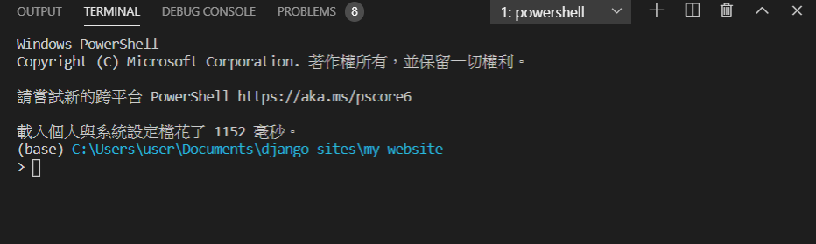

Now you can activate your python virtual environment.

>conda activate py37

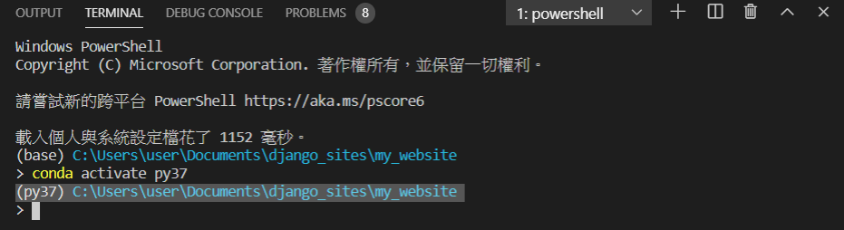

1. Install VS Code on Mac

VS Code is one of the best Editor in the world.

You can download Mac version from official website.



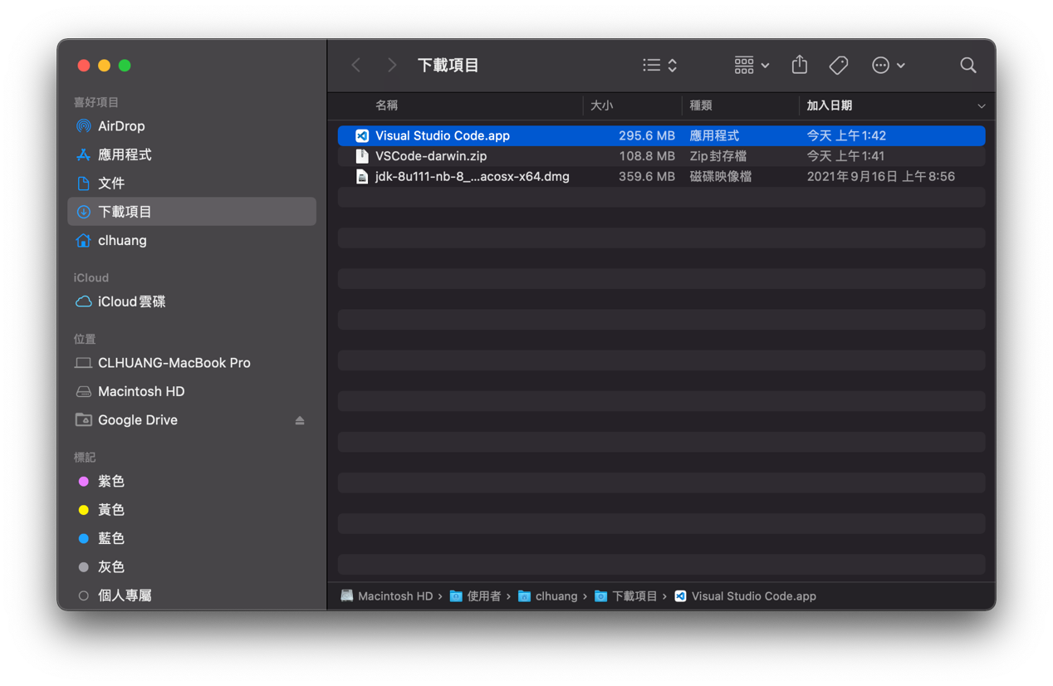

Installation[#](https://code.visualstudio.com/docs/setup/mac#_installation)

1. [Download Visual Studio Code](https://go.microsoft.com/fwlink/?LinkID=534106) for macOS.
2. Open the browser's download list and locate the downloaded archive.
3. Select the 'magnifying glass' icon to open the archive in Finder.
4. Drag Visual Studio Code.app to the Applications folder, making it available in the macOS Launchpad.
5. Add VS Code to your Dock by right-clicking on the icon to bring up the context menu and choosing **Options**, **Keep in Dock**.

Launching from the command line[#](https://code.visualstudio.com/docs/setup/mac#_launching-from-the-command-line)

You can also run VS Code from the terminal by typing 'code' after adding it to the path:

此步驟非常重要: Shell路徑設定

* Launch VS Code.
* Open the **Command Palette** (Ctrl+Shift+P) and type 'shell command' to find the **Shell Command: Install 'code' command in PATH** command.

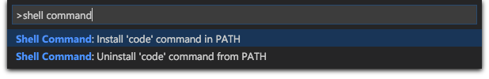

* Restart the terminal for the new $PATH value to take effect. You'll be able to type 'code .' in any folder to start editing files in that folder.

**Note:** If you still have the old code alias in your .bash_profile (or equivalent) from an early VS Code version, remove it and replace it by executing the **Shell Command: Install 'code' command in PATH** command.

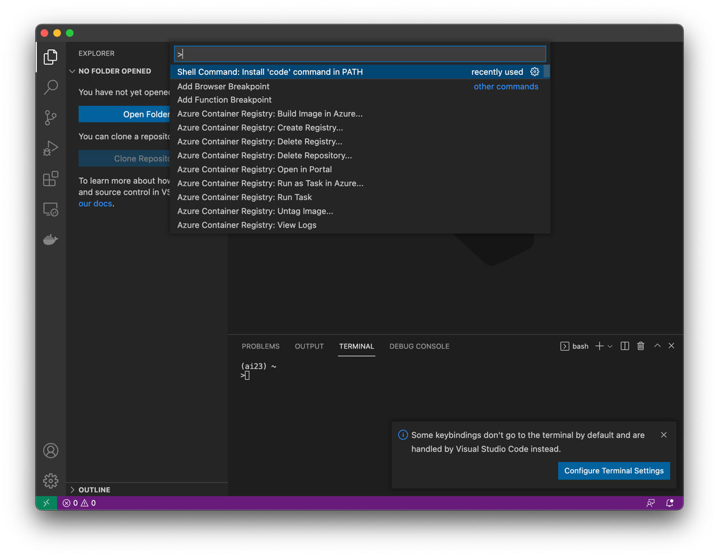

Official website for vscode installation:

<https://code.visualstudio.com/docs/setup/mac#_installation>

1. For mac users who fail to launch conda environment in terminal

可能有極少數同學會遇到此種情況。

在terminal中輸入

python --version

若能正確顯示版本3的python，應該能正常運作。

若是顯示版本2.7的python，則可能會有問題。

python3 --version

應能正確顯示版本3的python。

若你的vscode的terminal無法切換conda虛擬環境，必須做以下設定:

If you fail to activate conda environment in terminal on Mac. Please make sure the correct python path setting:

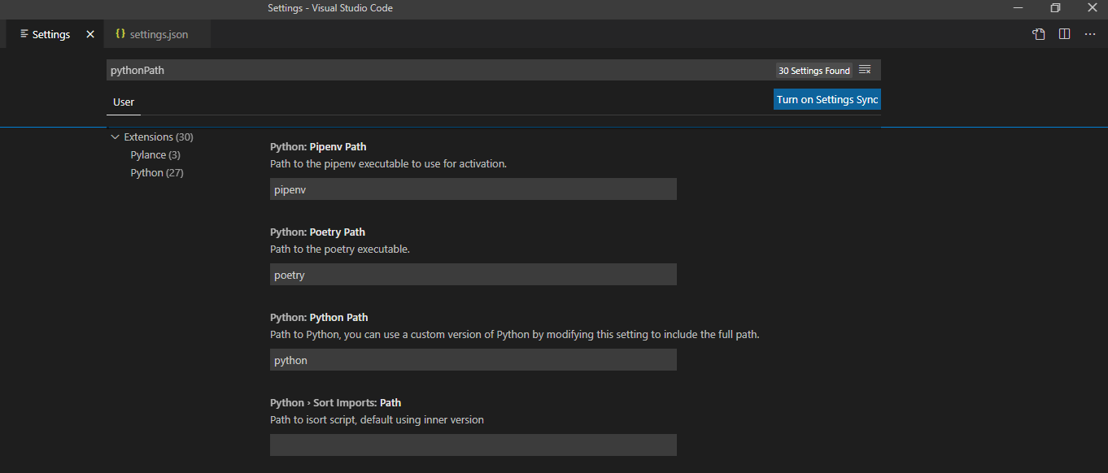

按下此符號進入json編輯模型

File - Preferences – Setting

查詢pythonPath

Mac的路徑

新增這一行，應該就可以了。

"python.pythonPath":"/Users/clhuang/anaconda/envs/py3/bin/python3",

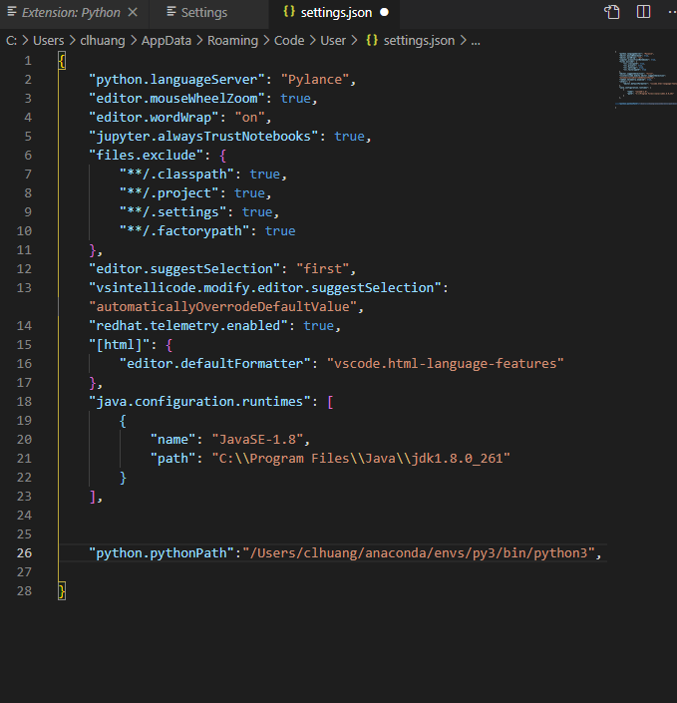

新增這一行讓Vscode知道python要用的版本是python3修改成你的python3路徑

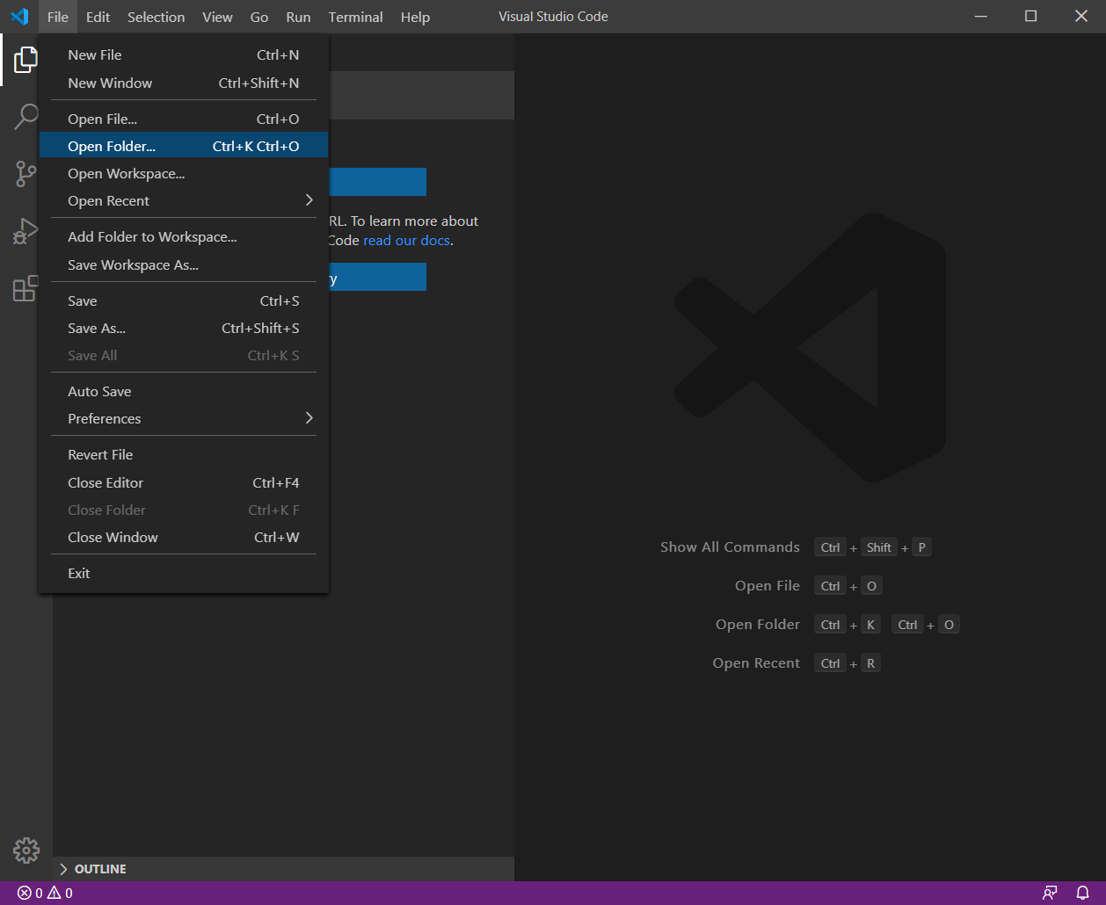

1. Install Anaconda or Miniconda

先要把Anaconda或Miniconda安裝好。

1. Set PowerShell to work properly

PowerShell是微軟新一代的命令列工具，把它設定好，Vscode會用到它。

**Enable to use conda command in Powershell**

$>conda init powershell

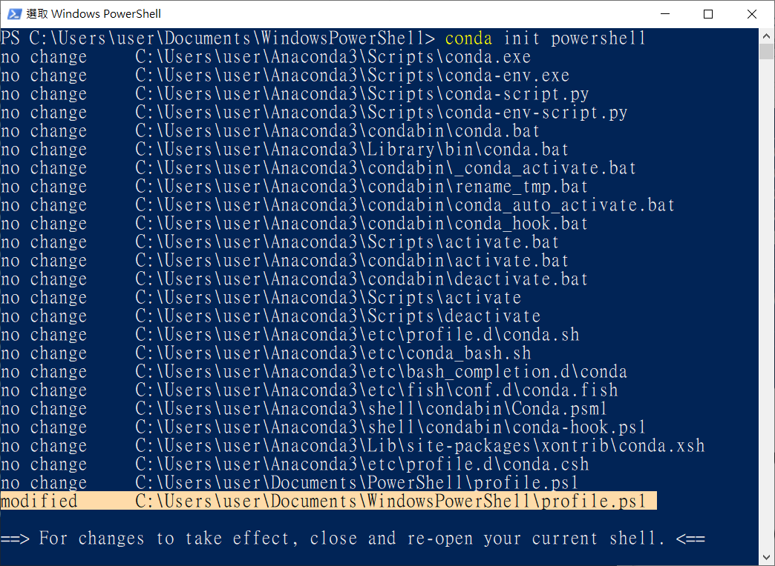

**Modify profile.ps1**

The profile of Windows PowerShell is located in your Documents directory.

The profile name is “profile.ps1”

“C:/Users/user/Documents/WindowsPowerShell/profile.ps1” 這個檔案自動產生，位於你的文件夾中，我們要進一步修改它。

“user” is the user name in my PC.

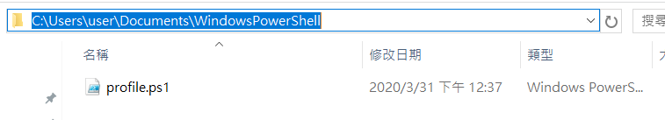

Note:

If you install PowerShell 7, the profile of PowerShell 7 is located in your Documents directory:

“C:/Users/user/Documents/PowerShell/profile.ps1” 如果你安裝PowerShell 7，設定檔自動產生於此，卷夾名稱有一些不一樣。

The following commands will be automatically inserted into the profile.

打開此設定檔，你會看到以下內容:

#region conda initialize

# !! Contents within this block are managed by 'conda init' !!

(& "C:\Users\user\Anaconda3\Scripts\conda.exe" "shell.powershell" "hook") | Out-String | Invoke-Expression

#endregion

1. Shorten Path in PowerShell縮短顯示路徑

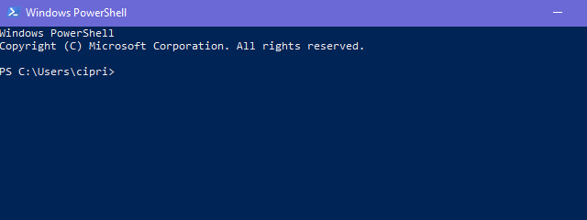

Path is too long!

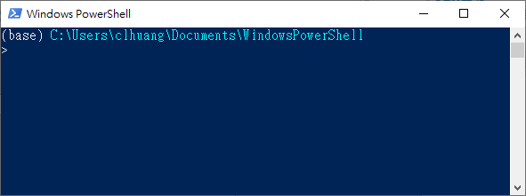

Path is shorten now.

**Modify profile.ps1**

The profile of Windows PowerShell is in your documents directory. The full path is as follows:

“C:/Users/user_name/Documents/WindowsPowerShell/profile.ps1”

If the file doesn't exist, then create it. Then place the following function in front of the profile script.

新增這一段命令文字

function prompt {

Write-Host $ExecutionContext.SessionState.Path.CurrentLocation -ForegroundColor Cyan

"$('>' * ($nestedPromptLevel + 1)) "

}

**Your profile.ps1 will look like:**

Now in the profile you will have the following scripts:

這一段文字要寫在最前面才可以!

完整的內容如下:

function prompt {

Write-Host $ExecutionContext.SessionState.Path.CurrentLocation -ForegroundColor Cyan

你的路徑會不一樣!

"$('>' * ($nestedPromptLevel + 1)) "

}

#region conda initialize

# !! Contents within this block are managed by 'conda init' !!

(& "C:\Users\user\Anaconda3\Scripts\conda.exe" "shell.powershell" "hook") | Out-String | Invoke-Expression

#endregion

Notice: the “function prompt” script should be placed before the “region conda initialize.”

function prompt必須要放在conda initialize之前，否則視窗畫面無法顯示虛擬環境的名稱，雖可運作，但有小瑕疵。

1. Set execution policy to “RemoteSigned”

Do you get the following message when opening PowerShell?

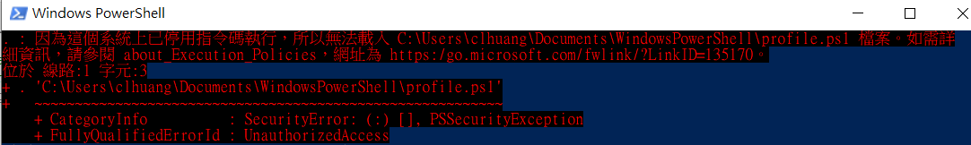

Update the PowerShell execution policy on the system to allow the script to run. In the PowerShell window, enter set-executionpolicy RemoteSigned. The system will prompt to confirm the change. Enter the letter Y or press the enter key to change the execution policy setting.

$>Set-ExecutionPolicy RemoteSigned

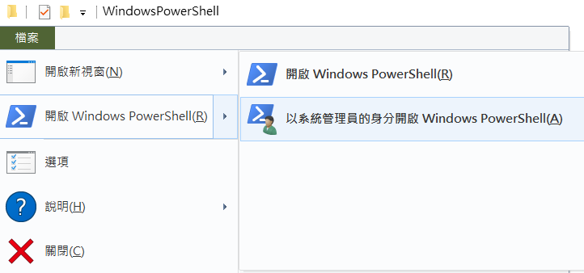

$>Set-ExecutionPolicy RemoteSigned

必須要在系統管理員身分下執行

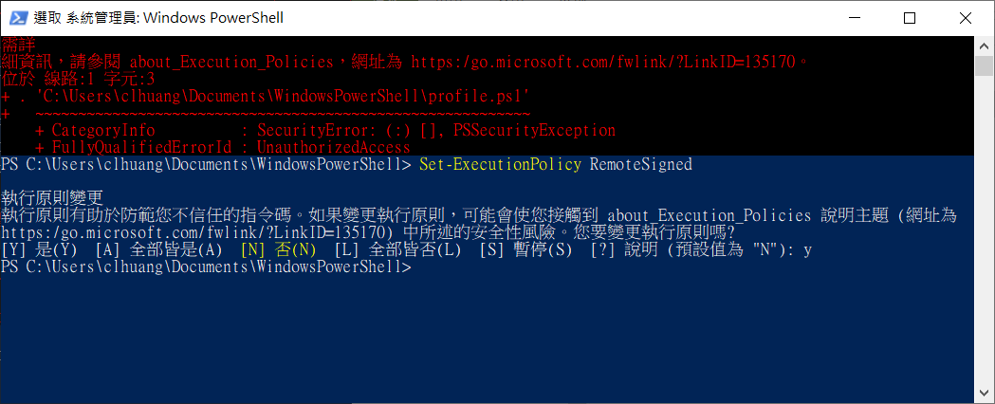

**「執行原則」**有下列 4 種：

Restricted ：關閉腳本檔的執行功能，這是預設的設定值。

AllSigned ：只允許執行受信任發行者簽署過的腳本檔。

RemoteSigned ：在本機電腦所撰寫的腳本檔，不需要簽署就可執行；但是從網際網路（例如：email、MSN Messenger）下載的腳本檔就必須經過受信任發行者的簽署才能執行。

Unrestricted ：任何腳本檔皆可被執行，但是於執行網際網路下載的腳本檔時，會先出現警告的提示視窗。

我們可以先利用 Get-ExecutionPolicy 來確認系統目前的指令檔執行限制為何：

Get-ExecutionPolicy

Check up the PowerShell execution policy on the system:

$>Get-ExecutionPolicy